AGRICULTURAL MECHANICS SKILLS

MIDDLE

TENNESSEE

FFA

AGRICULTURAL

MECHANICS

SKILLS

CAREER

DEVELOPMENT

EVENTS

Revised 2010

Preface

Revised: 2010

The intent of these skills is to be a part of the instructional program in Agricultural Education. All skills are part of the State Board of Education approved “Vocational Agricultural Curriculum Framework, 1985.” The intent of the FFA Skills contest is to use the competitive events as a motivator for students to perform better. The competitive events also are to serve as a reward for the students that excel in the agricultural mechanics skill areas as a result of the instructional program

During the time span of December 2008 though July 2010, the Middle Tennessee District Advisors polled the ag. ed. instructors in their representative districts to gather information on what revisions/updates were needed to better meet the demands of industry. Although this is an ongoing process, the following changes were made and approved by that group.

Plumbing – Add PEX component to fixture
Three-way Switch – Update as per codes recommendations
Oxy-Acetylene Brazing and Cutting – Add an extra piece of cutting metal to run a “PRACTICE CUT” before doing the competitive cut in exercise

The following general rules are still in effect from previous revisions:

The host chapter must be notified in advance of special needs for any contestant involved in a CDE. This will allow the host chapter to make arrangements to secure an individual to assist the member. (example: reading handicap)

Safety Glasses must be OSHA Approved and have side protection shields. Prescription glasses will not be sufficient for safety glasses.

A district that sends a SINGLE CHAPTER to represent their district to the Regional Ag Mechanics Competition instead of individual winners from each events is to BRING 3 ADVISORS from that respected district to help in judging the Regional Competition. This will help solve the judge shortage that will occur in this instance.

The Middle Tennessee FFA Agricultural Mechanics Skills CDE Rules and Regulations

may be found on the FFA Website.

Agricultural Mechanics CDE Regulations

(Revised August 2010)

“READ” ALL INSTRUCTIONS, DIAGRAMS, CODES, ETC. PRIOR TO CDE CONTEST FOR EACH CDE.

It is strongly suggested to place the Agricultural Mechanics CDE Rules and Regulations inside a page protector and file in a three ring binder with section dividers. This will allow for quick reference and replacement of only the pages involved in the event of a revision.

Contestants must provide all tools and supplies needed for their respective skills. Refer CDE ”Materials Needed” section.

Only active FFA members (currently enrolled in Agricultural Education) will be eligible to compete.

An FFA member may participate in only one skill.

- The Individual DISTRICT First Place winner in each skill will participate in the Regional CDE. First Pl In case the ace winner cannot participate, The First Place Advisor for that event will notify the Second Place winner’s Advisor and also their District Advisor.

- Each contestant must remain in the area designed for his skill until he is released by the person in charge of the skill.

- No one may coach or give assistance to contestants. Judges may disqualify a contestant when assistance has been given.

- Ag Ed teachers will serve as judges in the regional contest. Districts will be responsible for procuring their own judges.

- If any District sends the entire Ag Mechanics Team from one Chapter to the Regional CDE, that District will need to bring a MINIMUM of three Advisors to ensure that there are enough judges for all events.

- In REGIONAL Competition, Judges will rank the contestants through twelve places..

- POINTS toward the Awards Trophy will be allowed as follows:
PLACINGS: 1st 2nd 3rd 4th 5th Others
DISTRICT: (Chapter’s “OVERALL” TEAM District Placing) 15 13 11 9 7 5

REGIONAL: (“INDIVIDUAL” Participant in Each Skill Area): Placing Points
1st 16
2nd 14 (top 1/3 placings have weighted points for job well done)
3rd 12
4th 10
5th 8
6th 7
7th 6
8th 5
9th 4
10th 3
11th 2
12th 1

- Contestants must provide all tools and supplies needed for their respective skills. Refer CDE ”Materials Needed” section.

- A certain maximum amount of time will be allotted to each skill. No additional time will be given a contestant for being late. A notification will be given at end of time for each skill and all work must stop immediately. Unfinished products will be judged.

- A winner of a skill in the Regional Contest will not be allowed to participate in the same skill in following contests.

- Each contestant must register prior to the contest in his/her skill and no substitutes, or additions, will be allowed after registration.

- All contestants must wear safety glasses that are OSHA Approved and have side protection during competition and at all times that they are in the contest area except for students competing in land measuring and land elevation. Prescription Glasses will not be sufficient for safety glasses.

- The contestant will be disqualified for the removal of safety glasses except when cleaning the lens.

- The host chapter is to be notified in advance of special needs for any contestant involved in a CDE. This will allow the host chapter to make arrangements to secure an individual to assist the member. (example: reading handicap)

- In the event that a district were to send a single chapter from that respected district to the Regional competition, they are to bring at least three advisors from that district to help in judging the CDEs. This will help eliminate the shortage of advisors that will occur when only one chapter comes from a single district.

- Suggest to place CDE Materials in a three ring notebook

Laying Block
(revised 11/16/2001 & 7/9/2003 Crimson Clover District)

Materials to furnished at site of contest:

- Rating Sheets
- Hose
- Water
- Tar paper or suitable area covering (if desired)

Materials to be furnished by contestant

- Three CORNER and Three STRETCHER Blocks
- Mortar boards
- Pails (if needed)
- Wheel barrow
- Hoe
- Soapstone
- Square-nosed, short-handled shovel
- Enough Sand for laying 6 blocks
- Enough Dehydrated Lime for laying 6 blocks
- One trowel
- One level
- One “S” jointer
- One six-foot folding ruler
- One carrying bag (if desired)
- One pencil
- One framing Square
- One Brush or Burlap Sack to clean blocks
- Safety Glasses must be worn while performing task or the contestant will be disqualified. Exception is only when cleaning the lens of their safety glasses.

Procedure for student doing skill:

- Mix Sand and Dehydrated Lime “on site” for the block laying exercise.
- Square corner on concrete shop floor, driveway, or other existing suitable hard surface. (covered with tar paper if
desired)
- Lay a corner masonry unit using three 8” x 8” x 16” corner blocks and three 8” x 8” x 16” stretcher blocks.
(two- or three-core blocks may be used)
- Joint the blocks.
- Clean the blocks with the use of a brush or burlap bag.

Procedure for judging:

- Judges will be present to observe the proceeding of the entire contest.
- Observe the thickness of the mud mixture.
- Observe the correctness of design, neatness, speed, block and tool manipulation.
- Observe the correctness of height, level, plum, square, uniform joints.
- Contestants will be allowed one hour to complete the exercise.
BLOCK LAYING
SCORE SHEET

Contestant 1 2 3 4 5 6 7 8 9 10 11 12
Height
10 Points
Level
10 Points
Plumb
10 Points
Neatness
10 Points
Correct
Design
10 Points
Square
10 Points
Manipulation
10 Points
Uniform Joints
10 Points
Production
(Speed)
10 Points
Mud Mixture
10 Points
Total
Points
100 Points

RANK: 1ST 5TH 9TH

2ND 6TH 10TH

3RD 7TH 11TH

4TH 8TH 12TH
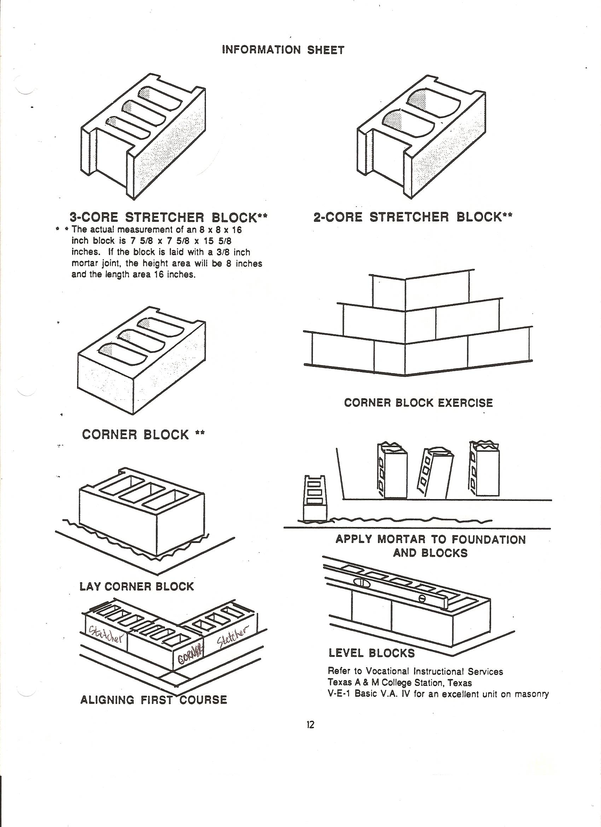
Rafter Cutting
(Revised 2/5/02 & 7/9/2003 by Crimson Clover District)

Materials to be furnished at site of contest:

- Two 2” x 4” x 8’ or 10’ for Rafter Ties
- Two 2” x 6” x 8’ (square edge) for Rafter Plates to nail Rafters
- Plates provided at proper distance (determined by judge)
- Four Blocks to elevate the Rafter Plate Frame off of floor

Procedure for students in doing skill:

- Layout and make pair of rafters including:
-Upper Plumb Cut
-Bird’s Mouth
-Horizontal Projection (overhang).
- Contestants will measure Span set up by Judge(s).
- Judge(s) will give contestants the following specifications:
-Rise per Foot of Run
-Horizontal Projection (overhang)
- Bird’s Mouth is to be 2” from top line of rafters, measured perpendicular from the top of the rafter.
- Safety Glasses must be worn while performing task or the contestant will be disqualified. Exception is only when cleaning the lens of safety glasses.
- Saw Rafters using tools from the lists below.
- Nail pair of rafters together at Upper Plumb Cut. Then nail to the plates.
- Contestant may get another contestant in Rafter Construction to hold rafters while nailing.
- Maximum time allowed for skill is One (1) Hour.

Materials to be Provided by Contestant

- Safety Glasses
- Clear Clipboard, clean paper, pencil, calculator (writing information given by judge and figuring exercise)
- Provide two 2”x4”x8’ (with square edge) for cutting Rafters
- Power tools that may be used are as follows:
-Circular Saw
-Jigsaw
-Reciprocating Saw
-Power Miter Saw
- Extension cord
- Hand tools that may be used are as follows:
-Handsaw
-Rule or Tape Measure
-Calculator
-Framing Square
-Saw Horse(s)
-Clamp
-Claw Hammer
- Nails

Procedure for Judging:

- Observe length and cuts.
- Observe erected pair of rafters as to fit at:
-Upper Plumb Cut
-Ridge
-Bird’s Mouth
- Observe the rise.
- Observe as to horizontal projection (overhang) and lower plumb cut.
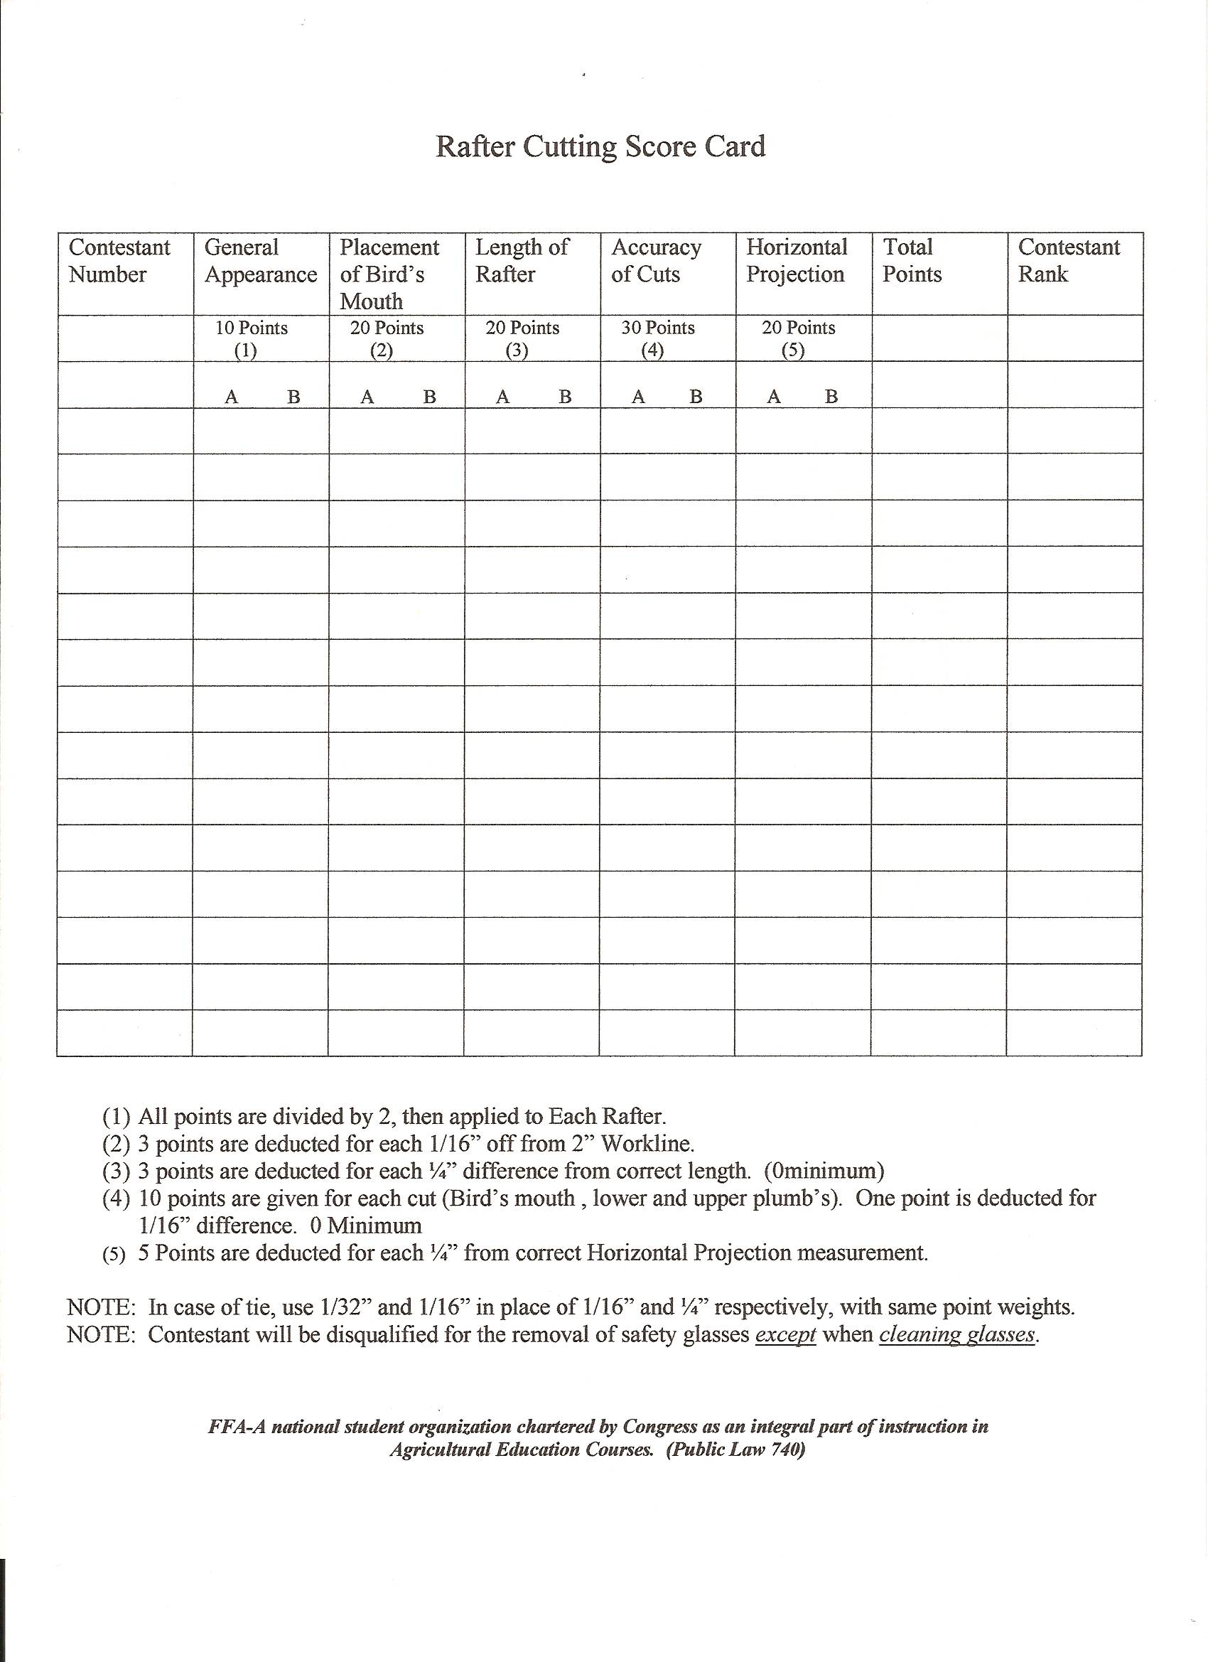

BOARD FITTING
(Revised 11/16/02 by Crimson Clover District)

Eligibility:

The skill is for enrolled first-year Agriculture Education students. If a Junior High and a Senior High FFA Chapter both exist for a school, and since the Senior High is ineligible to participate, the Senior High Chapter will receive the points earned by the Junior High Chapter.

Materials to be furnished at site of contest:

Area for CDE to be conducted

Materials to be furnished by contestant:

- A 2” x 6” x 24” board with uneven ends checked by judge.
- Tools allowed:
-handsaw (no miter saw or backsaw)
-square
-rule or tape measure
-pencil
-saw horse
-clamp
3. Safety Glasses

Procedure for student in doing the skill:

- Cut board to length determined by judge.
- Only one (1) cut may be made on each end.
- The clamp may be used to hold board steady.
- No jig of any type may be used.
- Time limit shall be thirty (30) minutes.
- Safety Glasses must be worn while performing task or contestant will be disqualified. Exception is only when cleaning lens of glasses.

Procedure for judging:

1. Length 40 points
2. Horizontal Squareness (6”) 20 points (10 points each end)
3. Vertical Squareness (2”) 20 points (10 points each end)
4. Correct use of tools 20 points

BOARD FITTING
SCORE SHEET

***Contestant will be Disqualified for the Removal of Safety Glasses Except when Cleaning Them.

*Length: Deduct 1 Point for Each 1/16” off**

Contestant 1 2 3 4 5 6 7 8 9 10 11 12
*Length
40 Points
Horizontal
Squareness
20 Points
(10 Points Each End)
Vertical
Squareness
20 Points
(10 Points
Each End)
Correct Use of Tools
20 Points
Total
Points
100 Points

PLUMBING

(Revised 8/8/2010 by Parks District)

Procedure for Skill:

- Contestant will measure template board once and record the distance center to center of nails for the upright position of the copper and plastic, pvc, pipe. (E)
- Galvanized tee shall be centered between the copper and plastic pipes and centered on the template at centering nail and upright copper and plastic pipe will lay between the nails contestant measured. (copper pipe on left and plastic pipe on right)
- Cut all pipe to required lengths.
- Prepare pipe: ream, thread, remove burrs, clean, and apply cement, solder, Teflon tape, or joint compound.
- Assemble according to exercise plan.
  - Leave 1 to 1 ½ threads showing past galvanized fittings.
  - Plastic and Copper adapters tighten until a secure joint is achieved.
  - Use Teflon tape or joint compound on all male fittings attaching to galvanized fittings.
  - Use copper crimp rings for pex tube
- Lengths of pipes A, B, C, and D are the same (minimum of 10 inches long) to be given by the judge.
- Contestants will be allowed a maximum of one hour to complete the project.
- Contestant will be disqualified for the removal of safety glasses except when cleaning safety glasses lenses.
- Refer to Illustration Page for exercise example.

Procedure for Judging:

- Check pipe measurements by using template. 25 points
2. Check assembly to see if according to plan 10 points
3. Check general appearance 15 points
4. Check for water leaks by applying 100 p.s.i. air pressure to fixture while 50 points
submerging in a bucket of water.

Materials to be provided by host:

- Template, 1” x 10” x 24”, for laying out fitting exercise.
- Five, eight-penny finishing nails for setting
- Air Hose and source.
- Shut off valve with pressure gauge to attach to fixture. (refer to Illustration for Valve construction)

Template set-up by judge:

- Judge drive two pairs of eight penny nails into the board and in a straight line from each other at predetermined distance.
- This predetermined distance shall be 12”, or more, apart.
- Place 5th finishing nail three (3) inches below two paired nails to center Galvanized Tee
- The nails for the Copper tubing side shall be ¾” apart
- The nails for the CPVC tubing shall be ¾” apart. (this will need to be 1” for PVC pipe.)

PLUMBING (continued)

Materials to be furnished by contestant:

- Galvanized pipe and tools:
  - 18” of ½” galvanized pipe
  - One ½” galvanized tee
  - Pipe joint compound or Teflon tape
  - Pipe vise
  - Pipe cutter.
  - ½” pipe hread die and ratchet
  - Pipe Reamer
  - Pipe Wrench
  - File
- Copper pipe and tools:
  - 18” of ½” hard copper tubing
  - One ½” copper elbow
  - One ½” copper cap
  - One ½” copper to galvanized adapter
  - Copper tube cutter or hack saw
  - Steel wool or emery cloth
  - Paste or acid flux for copper sweating
  - “Lead Free” and “Acid Free” silver bearing solder
  - Butane torch or any other source of heat
  - Clean wiping cloth
- Plastic pipe and tools:
  - 18” of hard CPVC or PVC plastic pipe
  - One ½” CPVC/PVC elbow
  - One ½” CPVC/PVC cap
  - One ½” CPVC/PVC plastic to galvanized adapter
  - Hacksaw or Tubing Cutter
  - Sandpaper or emery cloth for dressing cuts
  - Plastic pipe cleaner
  - Purple Primer
  - Plastic Pipe cement
- Pex tube and Tools:
  - 18” of pex tube 5/8” OD (should be ½” ID)
  - One ½” pex to galvanized adapter
  - One ½” pex to air manifold adapter
  - Two copper crimp rings
  - Tubing cutter
  - Sandpaper or emery cloth for dressing cuts
  - Crimping tool
- Tools & Equipment
  - Safety Glasses
  - Adjustable Wrench or combination wrench for adapters
  - Lubricating Oil
  - Can or tub to catch excess lubricating oil when threading pipe

PLUMBING

SCORE SHEET

*Water Leaks will be tested by Judge attaching valve to Galvanized pipe of exercise.

*100 p.s.i. of Air Pressure will be applied and placed in a bucket or tub of water where leaks will be
evident.

***No student is to be involved in administering this test.***

Contestant | 1 | 2 | 3 | 4 | 5 | 6 | 7 | 8 | 9 | 10 | 11 | 12
Fits
Template
25 Points

Correct
Assembly
10 Points

General
Appearance
15 Points

Water Tight (100 psi)
50 Points

Total
Points
100 Points

Rank: 1st 5th 9th

2nd 6th 10th

3rd 7th 11th

4th 8th 12th

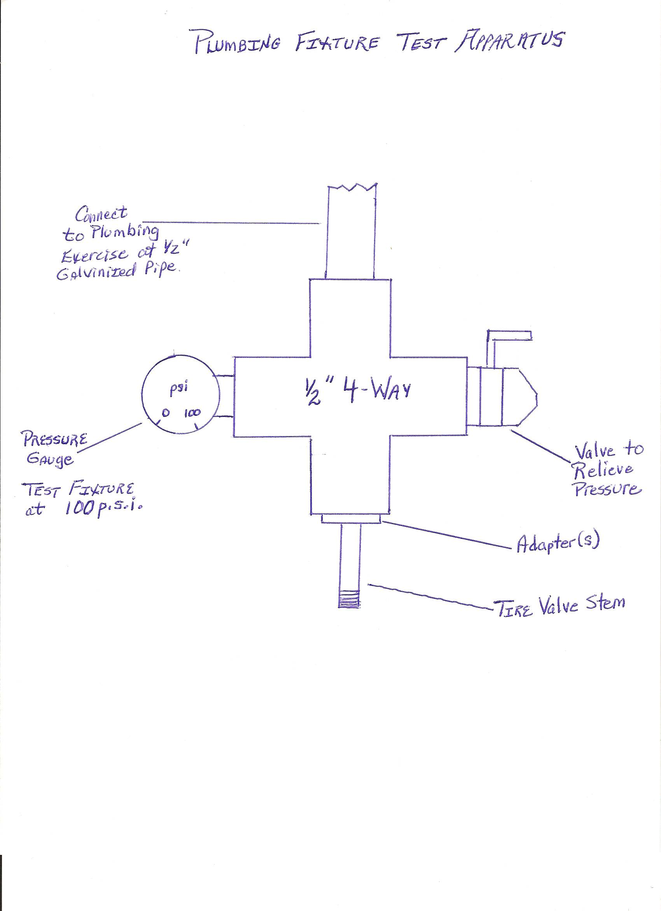
Attach to plumbing exercise at ½” pex pipe
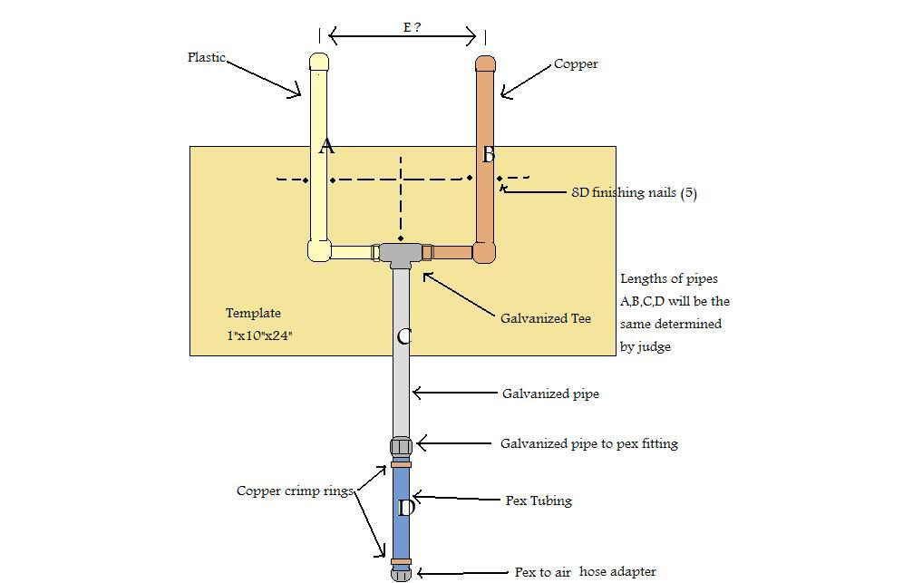

ARC WELDING
(Revised August 2003)

Materials to be Furnished at Contest Site

- AC Welders
- Welding Tables
- Machinist Vise and Shop Hammer to Test Welds

Materials to Furnished by Contestant

- Safety Glasses
- Six pieces of Mild Steel ¼” x 3” x 4”
- Welding helmet
- Chipping hammer
- Wire brush
- Welding gloves
- Electrodes of choice
- Square
- Soap Stone
- Vise Grips / Clamps

Procedure for Contestant Doing Skill

- Safety Glasses must be worn (refer to Rules and Regulations)
- Contestant check welder
- Turn on welder
- Run trial bead on one piece of metal
- Make any adjustment necessary to amperage
- Center top, upright piece of metal length wise to bottom piece of Mild Steel – “T” (refer to illustration)
- Run single Horizontal 1/4” Fillet Weld on one side of “T” pieces of metal
- Chip off slag with chipping hammer and wire brush weld
- Turn in to Judge
- Repeat steps 3 – 4 – 5
- May Tack Weld ONLY“T” in Horizontal Position to secure pieces for Vertical Weld
- Run single Vertical 1/4” Fillet Weld, bottom up, on one side of “T” pieces of metal (lap weld)
- Chip off slag with chipping hammer and wire brush weld
- Turn in to Judge
- Turn Welder off and remove any tools and equipment belonging to contestant
- No Touching Up of Either Weld

Procedures for Judging

Explain the use of the specific welder to all contestants

Safety - Safety Glasses Must be Worn!!!! Lack of use will result in disqualification!!
- Technique in use of equipment
- Efficiency and Speed
- General appearance as evidenced by smoothness, lack of splattering, etc.
- Strength of weld as evidenced by penetration, leg length, and lack of under cutting leg
(refer to illustration concerning bending exercise over to test strength and penetration)
- Horizontal and Vertical Welds centered

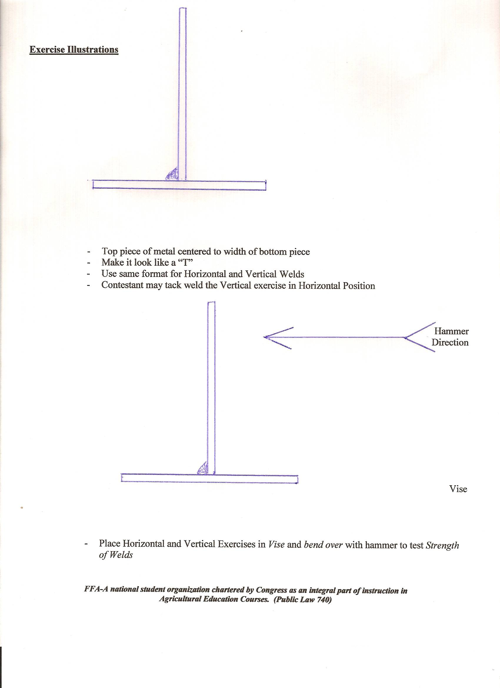
ARC WELDING
SCORE SHEET

Contestant 1 2 3 4 5 6 7 8 9 10 11 12
Technique
In Use of
Equipment
5 Points
Efficiency & Speed
10 Points
General
Appearance
20 Points
Vertical “T”
Centered
20 Points
Strength
- Penetration
15 Points

- Lack of
Undercutting
15 Points
- Leg Length
15 Points

Total Points
100 Points

Rank: 1st 5th 9th

2nd 6th 10th

3rd 7th 11th

4th 8th 12th

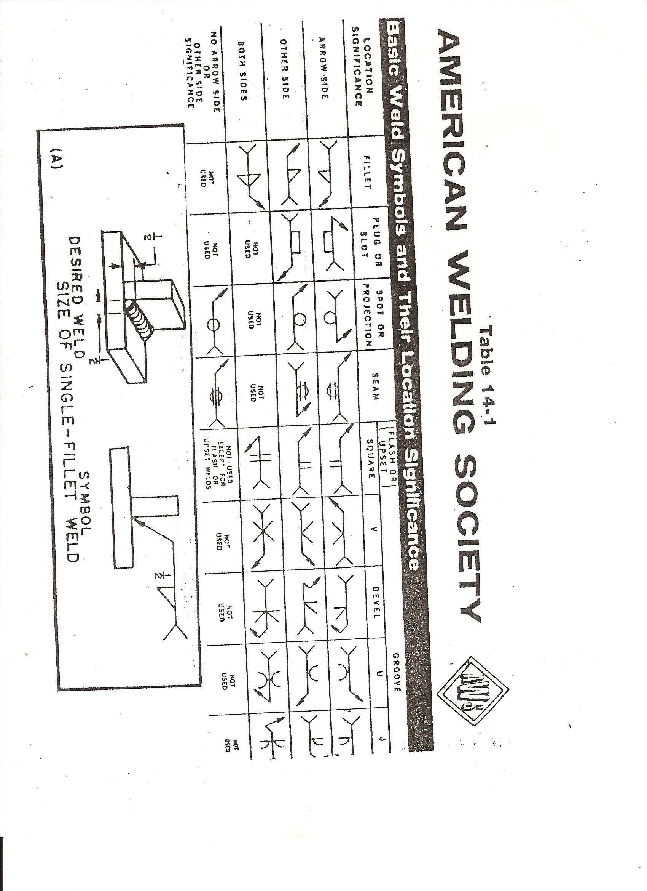

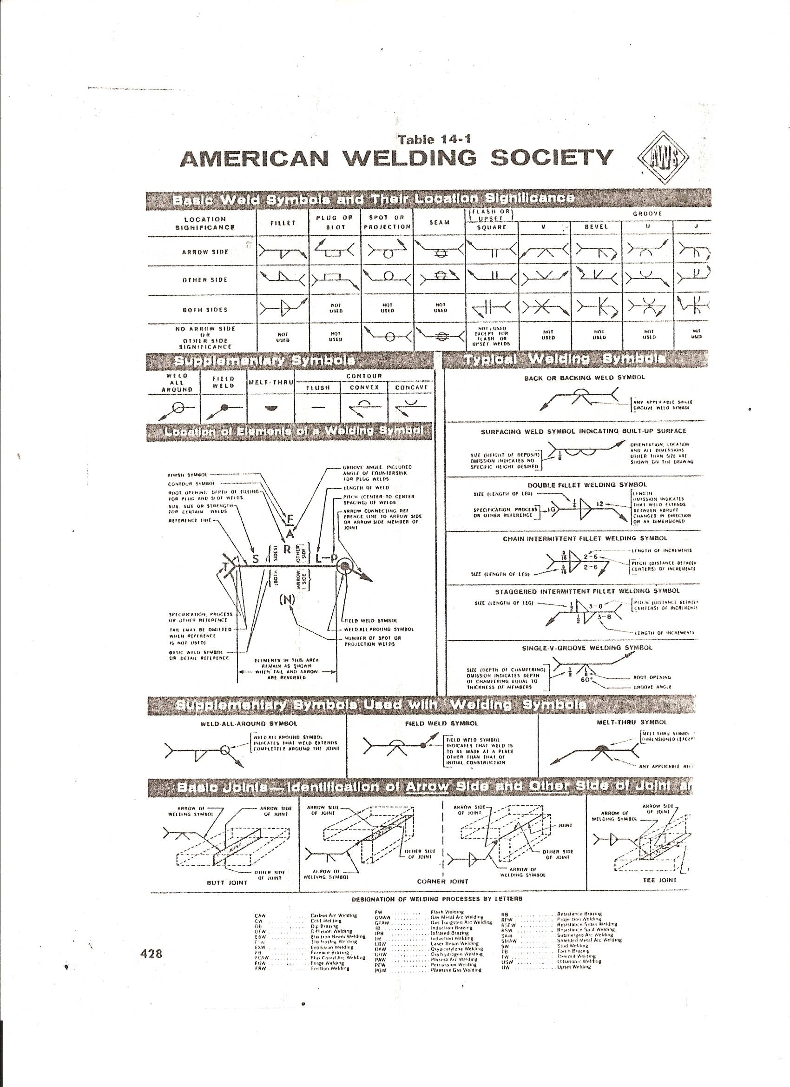
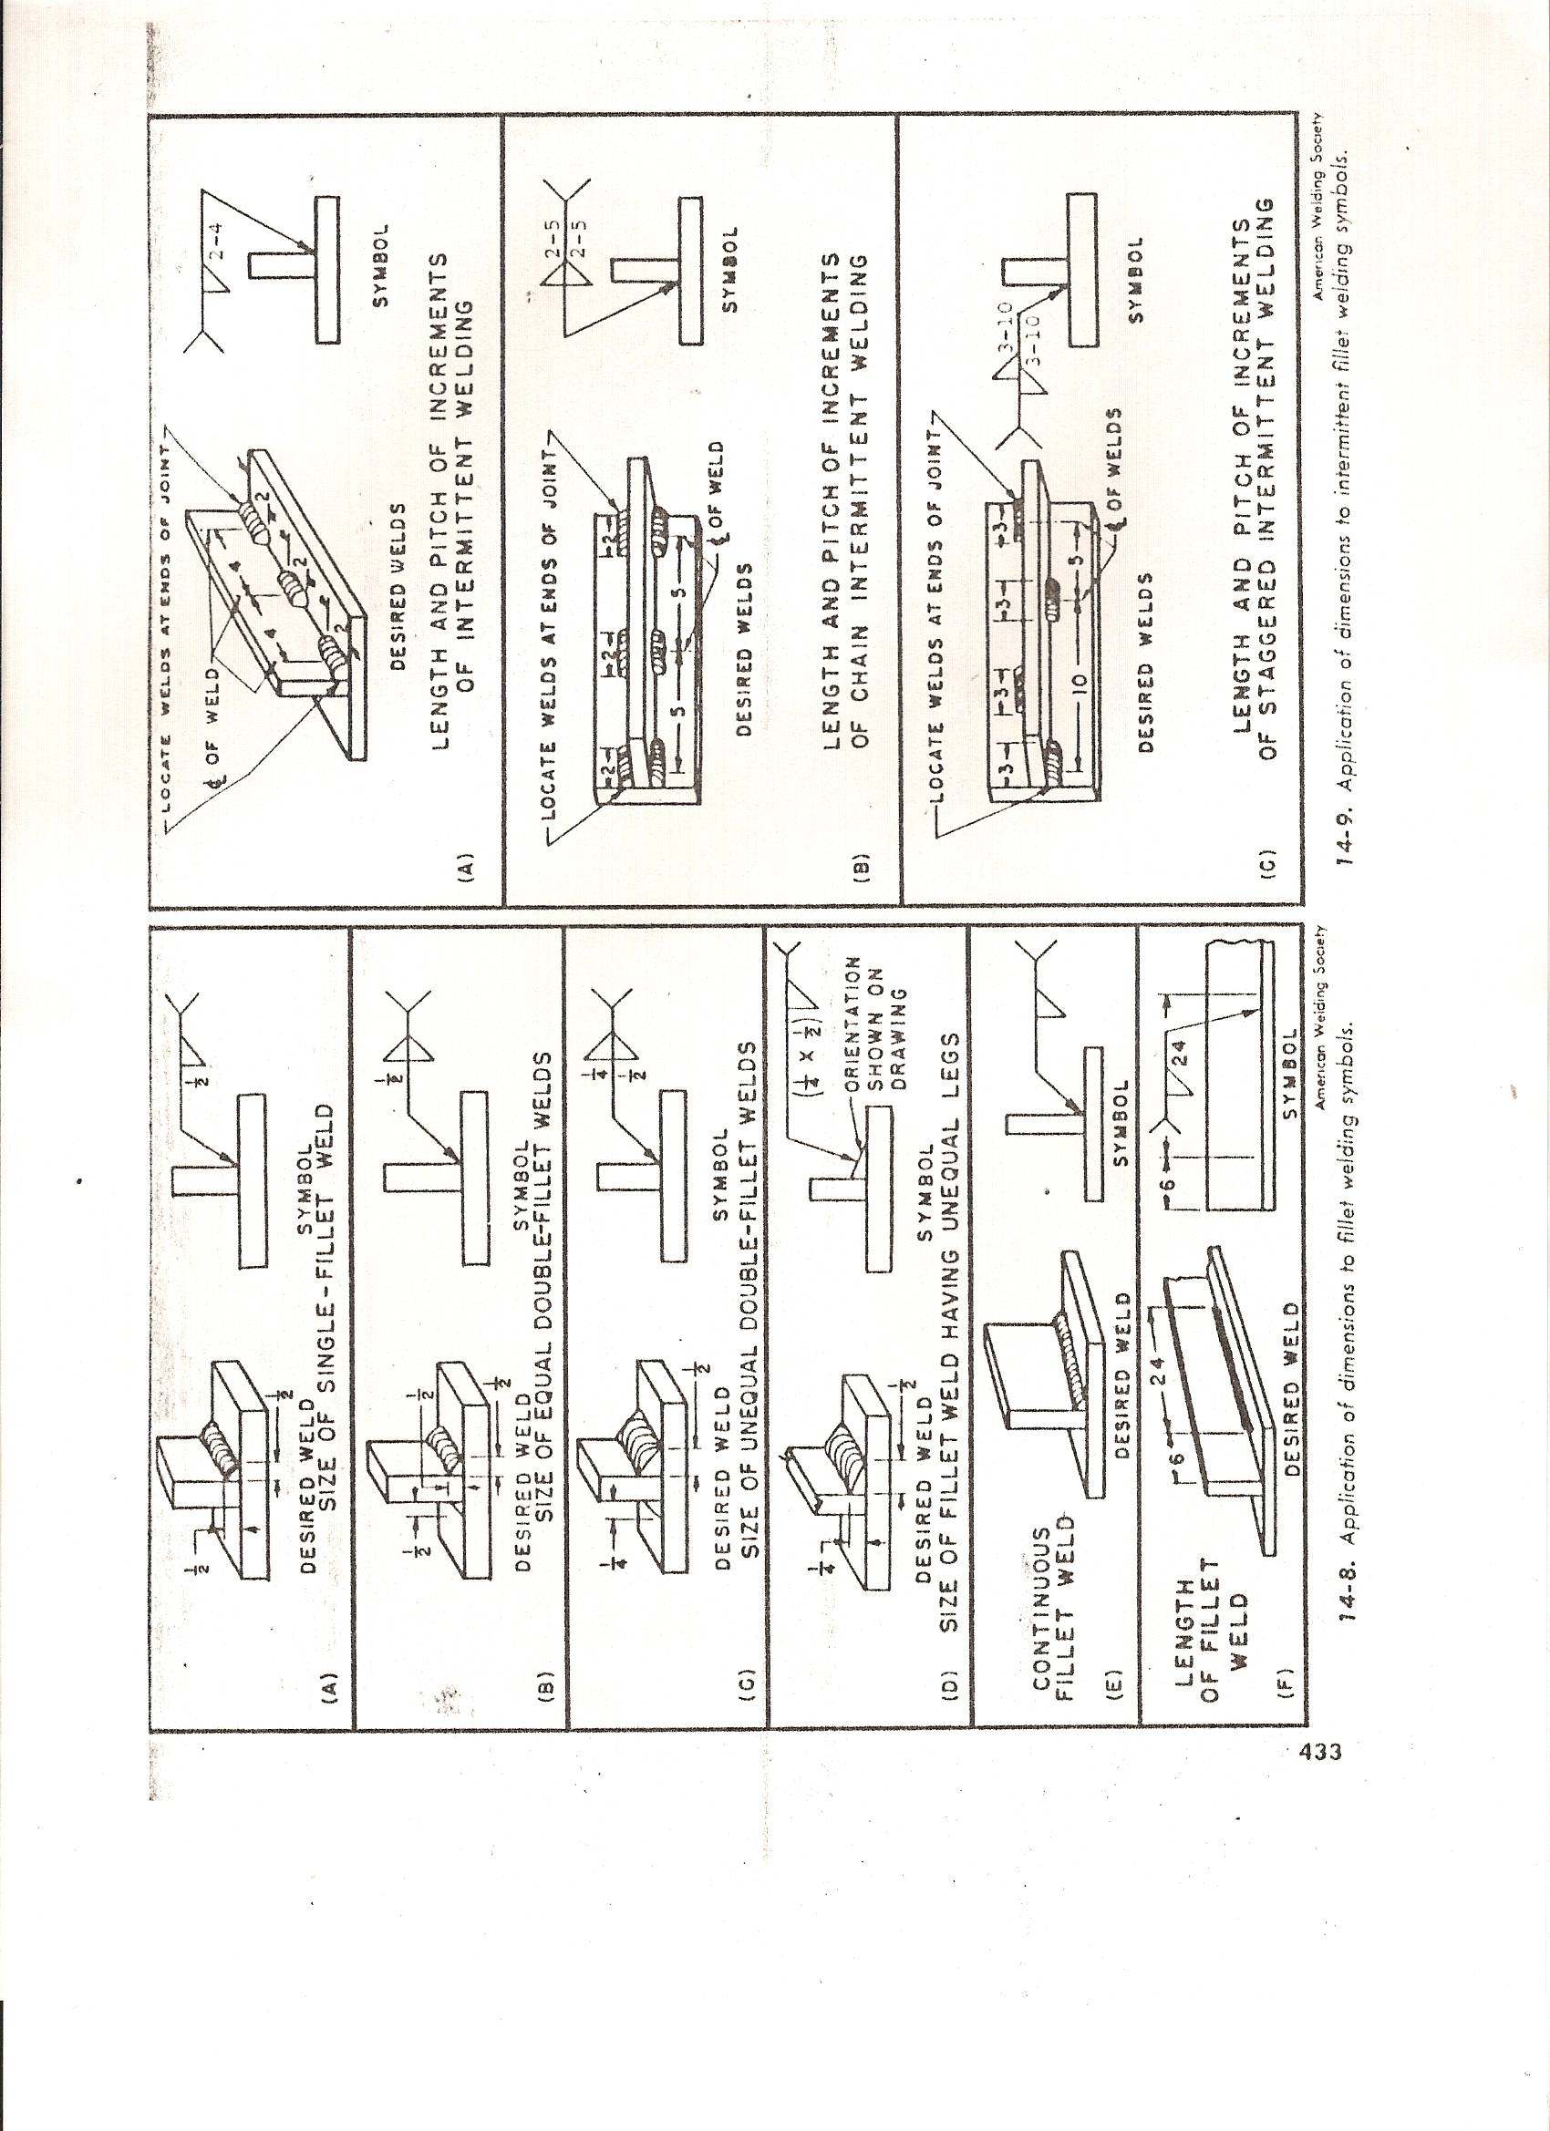
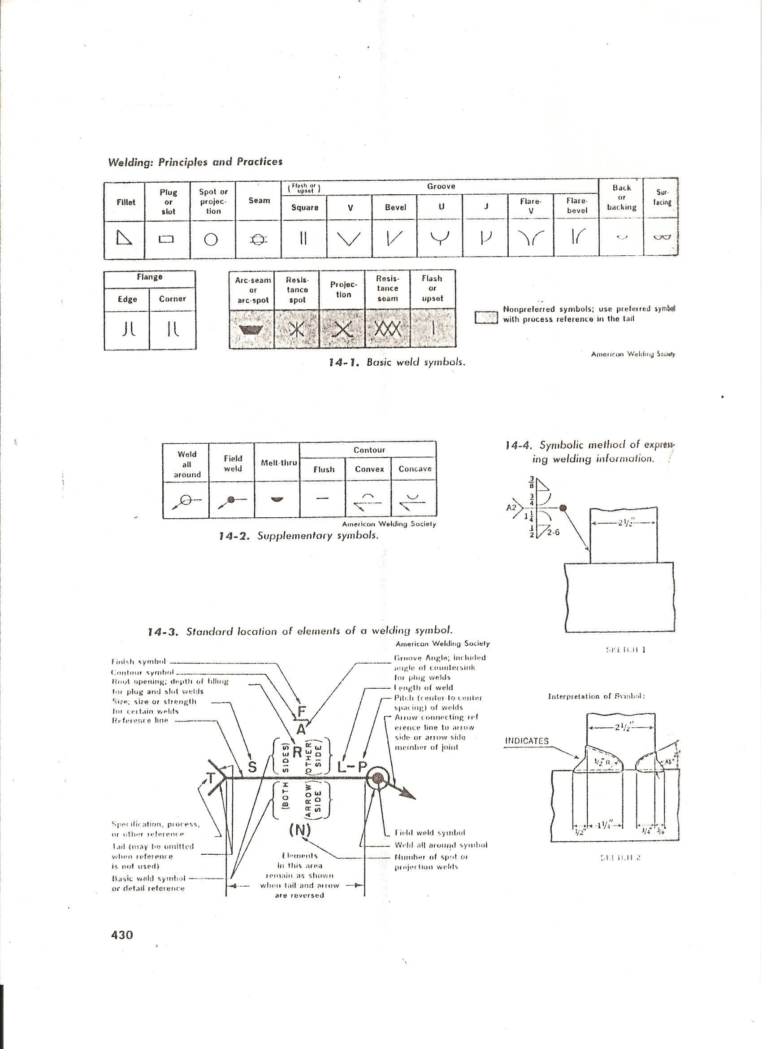
DIFFERENTIAL FARM LEVEL
(Revised August 2003 Red River District)

Preparation of Contest Site

- Prior to the contest, an accurate method will be used to determine the difference in elevation between two points.
- Selection of points should allow the judges to determine elevation with one instrument setup.
- Correct readings should be insured by waving the rod or by making sure it is perfectly vertical.
- The starting and ending points will be designated on permanent bench marks such as concrete steps, walks, or fire hydrants.
- Blank Field Note forms for field notes will be provided at site.
- For Official Results, it is strongly recommended to use the UT Extension Service, Soil Conservaiton, or Professional Land Surveyor.

Procedure for completing CDE Exercise

- Safety Glasses are not required for this contest.
- A three or four screw Bostrom Level or one of equal quality and magnifying power will be used.
- Auto-Leveling (Self-leveling without contestant’s assistance) instruments and instruments which assist in leveling will not be used. Definition of Self-Assisted Leveling is when the Level is rotated upside down by hand there is a "Clicking Sound" made. This is the Mirror making adjustment for level position inside the Level itself. This Level still requires leveling by 3 or 4 Screws, but will make final compensation by "floating" mirrors.
- Calculators that are not programmable nor graphing may be used.
- Clear Clipboards and paper should be free of notes.
- Only Field Note Forms will be provided at contest site.
- Contestants should bring all equipment needed to complete the contest.
- The judges will indicate that “Station A” has an Elevation of 100’.
- Judges will show the layout of the course.
- Each team will be required to set up Instrument a “Minimum of 3 Times”.
- A team may run the course only one time.
- Each team has a time limit of one hour to run course and turn in results.
- All Field Notes will be turned in on the form provided.
- Notes should be recorded on the Field Note Form in Feet to the nearest Hundredth. Not in feet & inches!
- A Positive or Negative Difference in elevation between “Station A” and “Station B” is to be determined by each team.
- Each team is to answer the additional question at the bottom of the Field Note Form.

Scoring

80 Points – Accuracy of difference in elevation between Station A and Station B
10 Points – Proper set up procedures, care of equipment, and use of instrument
10 Points – Accuracy, neatness, and legibility of field notes
100 Points Total

DIFFERENTIAL FARM LEVEL
FIELD NOTES
Two Pages may be issued if needed for longer runs.

Chapter Name: ______________________________

Contestant Name: _____________________________________

Contestant Name: _____________________________________

Station BS HI FS Elevation

A ______________ ______________

______________

TP 1 ______________ ______________ ______________

______________

TP 2 ______________ ______________ ______________

______________

TP 3 ______________ ______________ ______________

______________

TP 4 ______________ ______________ ______________

B

Difference in Elevation in nearest Foot/Feet and Hundredths - _____________________________

Is there an Increase or Decrease in Elevation? ________________________

DIFFERENTIAL FARM LEVEL
SCORE SHEET

Contestant 1 2 3 4 5 6 7 8 9 10 11 12
Start
Time
End
Time
Total
Time
Accuracy
80 Points
Procedure
10 Points
Field
Notes
10 Points
Total
Points
100 Points

RANK:

1st _________________________ 7th ________________________

2nd _________________________ 8th ________________________

3rd _________________________ 9th ________________________

4th _________________________ 10th _______________________

5th _________________________ 11th _______________________

6th _________________________ 12th _______________________

SMALL ENGINE
(Revised August 2003)

General Instructions

The skill will be performed by one contestant. The skill will consist of troubleshooting and repairing an engine which has been faulted by the judges. Each contestant is to deliver their engine to the judge prior to the start of the CDE. The engine will be labeled so that each contestant will work on their own engine. If the judge “faults” the engine with the replacement of non-funcitional parts, the contestant must ask for replacement parts. Points will be deducted if the wrong part is asked for. The engine must run properly after the faults are corrected. Contestants will take an exam while the judge faults the engines.

Materials to be furnished at the Contest Site

- Provide a crankshaft
- Engine with ring inserted in cylinder before contest
- Piston with compression rings
- Gasoline for Engines

These items are to be separate from any running engines that the contestant brings to contest.

Suggested Tools Contestants are to Furnish

- One six-inch or eight-inch clamp for securing engine to the bench when starting
- Suggested Basic Tools:
Soft or plastic faced hammer, brass hammer, needle nose pliers, 6” adjustable wrench, spark plug sockets, ¼” socket set, socket wrench for flywheel nut, Phillips standard screwdriver, Phillips standard screwdriver, carburetor screwdriver (B&S Stratton Special Tool), spark plug wire gauge and bender, leaf type feeler gauge, and dial caliper.
NOTE: digital dial caliper will not be used
- Tachometer
- Flywheel *holder, *wrench, *puller
- 4/02 Briggs and Stratton Service and Repair Manuel, Official Repair Manuel for CDE
- Spark tester
- Pencil and Clipboard for Exam
- Tool, or home-made too, to secure crankshaft while loosening and tightening Flywheel Nut to help reduce chance of breaking cooling fins on flywheel.

Engine Specifications

NOTE: The engine should be mounted on a board or stand that can be clamped to a table.

- Briggs and Stratton 5 ½ hp overhead valve engine (OHV)
- Must have Horizontal crankshaft
- Straight power shaft (no gear reductions)
- Recoil starter
- Crankcase properly filled with oil
- No Gasoline in the tank
- Engine should not have any missing or broken parts
- No parts are to be marked or labeled in any manner

Engine Faults Limited to:

- Flywheel key removed
- Flywheel pressure washer removed
- Flywheel nut loose
- Carburetor discharge nozzle removed or other such equipped high speed metering device
- Idle adjustment changed
- Ignition system grounded
- Air cleaner restricted
- Spark plug gap closed or changed
- Armature air gap changed
- Kill switch wire short
- Magnatron may be inverted (will not run if inverted, looks similar on both sides)

Judging and Scoring
(may use present score sheet)

I Observation of Work
a. Safety, dress and work habits 20 Points
b. Proper use of tools 20 Points

II Evaluation of Engine’s Performance: For the accuracy of speed adjustment, the contestant’s tachometer
will be used by the judge.

a. Idle Speed Accuracy 15 Points
b. Top Operating Speed Accuracy 15 Points

NOTE: Each Speed should be within Plus or Minus
50 rpm’s of Manufacturer’s specifications

III Measurements: Checking for Most Wear

Dial Caliper Use

No DIGITAL Calipers!!

a. Caliper reading of Crankshaft PTO end 10 Points
b. Caliper reading of Crankshaft Crankpin 10 Points
c. Caliper reading of Crankshaft Magneto End 10 Points

Feeler Gauge Use

a. Feeler Gauge reading of Ring Groove 10 Points
b. Feeler Gauge reading of Ring Gap 10 Points

IV Exam

Exam Possible Points 100 Points

V Time

The judge will record the time and order which students finish.
Time will be used to break a tie in points only!

SMALL GASOLINE ENGINE
SCORE SHEET

Contestant 1 2 3 4 5 6 7 8 9 10 11 12
Safety & Work
Habits
20 Points
Use of
Tools
15 Points
Idle
Speed RPM
15 Points
Top
Speed rpm
15 Points
Correction
Of Faults
80 Points
Crankshaft
P.T.O.
10 Points
Crankshaft
Crankpin
10 Points
Crankshaft
Magneto
10 Points
Ring Grooves
10 Points
Ring
Gap
10 Points
Written
Exam
100 Points
Total
Points
300 Points

Ranking: 1st 5th 9th

2nd 6th 10th

3rd 7th 11th

4th 8th 12th
LAND AREA MEASURING
(Revised August 2003)

Materials to Furnished at Contest Site

- Plot of Land a minimum of ½ Acre in size
- Stakes
- Official Answer Extension Service, Soil Conservation, Certified Land Surveyor

Materials to be Furnished by Contestants

- 100 foot tape measure marked in feet and inches, or feet and tenths
- Clear Clipboard, pencil and non-programmable, nor graphing calculator
- Flags, rods, pencil, etc. to mark their pulls greater than 100’ between stakes
- These contestant markers are to be removed as measurements are taken

Procedure for Contestants in Doing Skill

- Measure plot of land that has been staked off by the judges
- Measurements will be made from the center of the stakes
- Measure one time only
- 1 Hour to complete CDE Event
- Two students will work together on this skill
- Use only a 100 foot tape measure marked in feet and inches, or feet and tenths
- Answer will be to the nearest ten thousandths of an acre
- Figure will be divided into three triangles by contestants
- The Heron Method will be used for calculation of each triangle’s square footage
- A Calculator may be used
- Programmable Calculators are not to be used

Procedure for Judging

- Official will stake off area and calculate acreage to the nearest ten thousandths of an acre
- Dimension lines are to be straight and will include five sides, no more, no less
- Plot will be ½ acre or more including at least one 90-degree angle
- Corners will be marked by a maximum ½” diameter metal posts
- Measurements will be made at ground level
- The posts should be marked with flags on top for visibility
- The judge must identify the perimeter for contestants

Heron Method

Figure the Area for Each Triangle using the Following Method

S = A + B + C Use this formula for each Triangle
2

Take the Square Root of S (S-A) (S-B) (S-C) for each Triangle

Add All Three Areas of the figure and divide by 43,560 Square Feet to get Acreage

LAND AREA MEASURING
SCORE SHEET

*Teams Measure Course one time only
*Time Must be Kept on each team
**Time will be used to Break Ties Only**

 | TEAM 1 | TEAM 2 | TEAM 3
Time Started
Measuring
Time Calculations Complete
Total Time
1 Hour Maximum
Measuring
Answer
 | TEAM 1 | TEAM 2 | TEAM 3
Time Started
Measuring
Time Calculations
Completed
Total Time
1 Hour Maximum
Measuring
Answer
 | TEAM 1 | TEAM 2 | TEAM 3
Time Started
Measuring
Time Calculations
Completed
Total Time
1 Hour Maximum
Measuring
Answer
 | TEAM 1 | TEAM 2 | TEAM 3
Time Started
Measuring
Time Calculations
Completed
Total Time
1 Hour Maximum
Measuring
Answer

BRONZE WELDING AND CUTTING
(Revised August 2002)

Materials to Furnished at Contest Site

- Necessary Oxy-acetylene equipment with selection of tip sizes both, Brazing and Cutting
- Table
- Tip Cleaner

Materials to be Furnished by Contestant

- Three pieces of 16 gauge mild steel 2” x 6” (1 for heat setting, 2 for skill)
- One piece of ¼” x 3” x 4” Mild Steel for cutting. One additional like piece may be used for adjusting equipment and practice
- 3/32” Manganese Bronze rods either coated or bare
- Welding Goggles
- Brazing Flux (if using bare rods)
- Welding Gloves
- Safety Glasses – Contestant will be disqualified if safety glasses are not worn while chipping & cleaning exercise
- Brazing/Cutting Goggles
- Wire Brush
- Pliers

Procedure for Doing Skill

*Judge will explain the use of welding equipment to all contestants.

- Student check gas welding equipment
- Clean welding tip if necessary
- Use one piece of metal for adjusting flame
- Make Bronze Weld in fillet position with two pieces of metal
- Braze on one side only while in upright position (cannot lay in “V” format)
NOTE: Some sort of support may be used to hold vertical piece upright for tacking only! Then it must be removed while
performing the skill!
- The student will cut down the center of a ¼” x 3” x 4” piece of mild steel. A like practice piece may be used to adjust equipment. The practice piece will not be used for score.
- Contestant may use a soapstone for centering line for guide only, no jig
- A separate station will be provided for cutting if necessary
- Time limit of 30 Minutes

Performing Test on Braze

- View for inspection from front side and end
- Test joint strength by placing on anvil and flattening it down exposing the root side of the weld
- If joint is penetrated into corner, there will be no separation of plate at the root
- If joint is not penetrated, the plates will separate at the root

BRONZE WELDING AND CUTTING
SCORE SHEET

Contestant 1 2 3 4 5 6 7 8 9 10 11 12
Brazing:
Technique in use of Equipment
12.5 Points
Efficiency:
Speed & Accuracy
12.5 Points
Strength of Weld as Evidenced by Penetration
50 Points
General Appearance:
Smoothness & Uniformity
25 Points
Cutting:
Technique in Use of Equipment
30 Points
General Appearance:
Smoothness & Uniformity
30 Points
Straightness
& Cut down the Center
40 Points
Total
Points
200 Points

TOOL IDENTIFICATION
(Added August 2002)

Eligibility

- This skill is limited to FFA Members who are Freshmen and Sophomores.
- A student may enter this skill two years
- If student wins the Middle Tennessee Regional Competition as a Freshman, they are not eligible to compete in this skill again their Sophomore year.

Preparations for District CDE

- Delmar, Agricultural Mechanics – Fundamentals & Applications 4th Edition, UNIT 7 is the Official for CDE
- The Tools to be Identified will come from Unit 7.
- The Tool ID Exam will come from Unit 7.
- Examples of materials include: different types of pipe fittings, different types of screws, and different types of nails.
- All selections will be made from textbooks and other resources commonly available to instructors for training.
- The Written Exam will ask students questions about the use of the tools and materials on the list.

Materials Furnished at Contest Site

- Host will select 10 tools and 5 materials from Unit 7
- These will be numbered and placed on a table or other workspace for identification
- Judge will be arranged by host chapter

Materials Furnished by Contestant

- Clear, Clipboards (must be clean and no writing on them)
- Pencils
- No Paper or other Materials allowed
- Bring Safety Glasses
- Judge will determine if they are needed in the Environment of CDE

Procedure

- Use Test Sheet Provided taken from Unit 7
- Five (5) Minutes will be allowed to Identify the Tools and Materials
- Only the Name from the list will be accepted because of “common” names
- Students will compete separately
- No “Word Bank” or “Memory Aid” will be used
- Time needed by each contestant for identification will be kept by judge
- Students will be given a maximum of Ten (10) Minutes for the Written Exam
- Exact time used for Written Exam is not needed
- Papers collected at the time limit for each section

Scoring

- 100 Points Total Score – 90 for Tool Identification & 10 for Written Exam
- Tool Identification Time will be used as a Tie Breaker
- Contestant will not be penalized for spelling errors
- Written Exam will be Multiple Choice
- Contestant suspected of cheating will be disqualified
TOOL IDENTIFICATION
EXAM SHEET

Contestant Number: ________

Chapter: _________________________

Contestant Name: _________________________

You will be given Five Minutes to complete the Tool Identification. Please have materials ready and ask any questions you may have before the time begins. Time for the Tool Identification will be used only to break a tie.

Each tool is numbered. Write the Name of the Tool beside the matching number. Turn in you paper as soon as you complete it.

- ____________________________________

- ____________________________________

- ____________________________________

- ____________________________________

- ____________________________________

- ____________________________________

- ____________________________________

- ____________________________________

- ____________________________________

- ____________________________________

- ____________________________________

- ____________________________________

- ____________________________________

- ____________________________________

- ____________________________________

TOOL IDENTIFICATION
SCORE SHEET

Contestant 1 2 3 4 5 6 7 8 9 10 11 12
Tool Identification
15 Tool ID’s
(5 Points Each)
Written
Exam
(10 Questions)
(2.5 Points Ea.)
Total
Points
100 Points
Tool Identification
Time
(Tie Breaker)

Rank:
1st 5th 9th

2nd 6th 10th

3rd 7th 11th

4th 8th 12th

3-WAY ELECTRIC SWITCH INSTALLATION

(Revised August 2010, Mike Akridge)

Options for Wiring

Person in charge of CDE shall determine by lot, which of the three types of 3-Way Switch is to be constructed.

- Light between switches, source of energy at light
- Light before the switches, source of energy at light
- Light beyond the switches, source of energy at switch most distant from light (8” from base)

Minimum Materials to be Furnished by Contestant

- Safety Glasses: Contestant will be disqualified for not wearing Safety Glasses during CDE, except when cleaning them.
- Two Plastic wall boxes 3” x 2” x 3” or comparable; One for Switch, One for Duplex (mount to frame before CDE)
- One Metal wall box 3” x 2” x 3” or comparable (mount to frame before CDE)
- One Duplex Receptacle with green screw
- One Pre-Fabricated Power Source Cord for Duplex Receptacle.
- One 4” plastic or metal ceiling box (mount to frame before CDE, must be large enough for the number of wires in the box)
- One Porcelain light Receptacle
- 14/3 non-metallic sheathed cable with ground 5 Feet Long ; 14/2 non- metallic sheathed cable with ground 8 feet long. (judges note: students should not be penalized for using #12 wire since this could be a 15 amp or 20 amp circuit. However, only one size wire can be used throughout the circuit)
- Sufficient number of Solderless Connectors to fit above listed wires and green pigtails for grounding metal boxes
- Two Switch Box Covers
- One Duplex Receptacle Cover
- Wood Frame according to drawing
- Required number of ½” non-metallic sheath cable fasteners
- Necessary Tools to complete this CDE (power drivers are acceptable)

Materials Furnished at Contest Site

- Extension Cord six feet or longer for plugging male end of Duplex Receptacle Power Cord for testing lights
- Tables to mount Frames to for Event

Procedure for CDE Exercise

- This skill is designed to teach Electric Principles rather than Carpentry.
- Mount all electrical boxes on specified Frame before CDE
- BEFORE CDE EVENT: Construct an 18”, 14/2 non-metallic sheathed with ground, Male Plug on one end and 8” of sheath stripped on other end for insertion into the Duplex Box to serve as “Source” (should be 12/2 if using #12 wire in rest of the circuit).
- Male plug will plug into the Extension Cord for testing. Note to your students that this is not an acceptable wiring practice for codes, but is used in this exercise for safety reasons when connecting the project to an electrical source in the contest)
- Frame must be secured to table with clamp before contest begins
- All work must be completed with frame clamped to the table right side up
- Run a 14/2 cable with ground from the duplex receptacle box, through the 5/8” hole pre-drilled in stud
- Proceed to run 14/2 cable to designated for the source wire to enter (either the light, or switch box)
- Install wires in boxes (see score sheet for measurements)
- Connect wires to switches and to receptacles and line
- Solderless connectors (ie. wire nuts) used, wires in Solderless Connectors must be twisted together
- Connect and exit the 18” pre-fabricated “Source Cable with Male Plug” from the left side of the Duplex Receptacle box
- 1 Hour Time Limit to complete this CDE Event

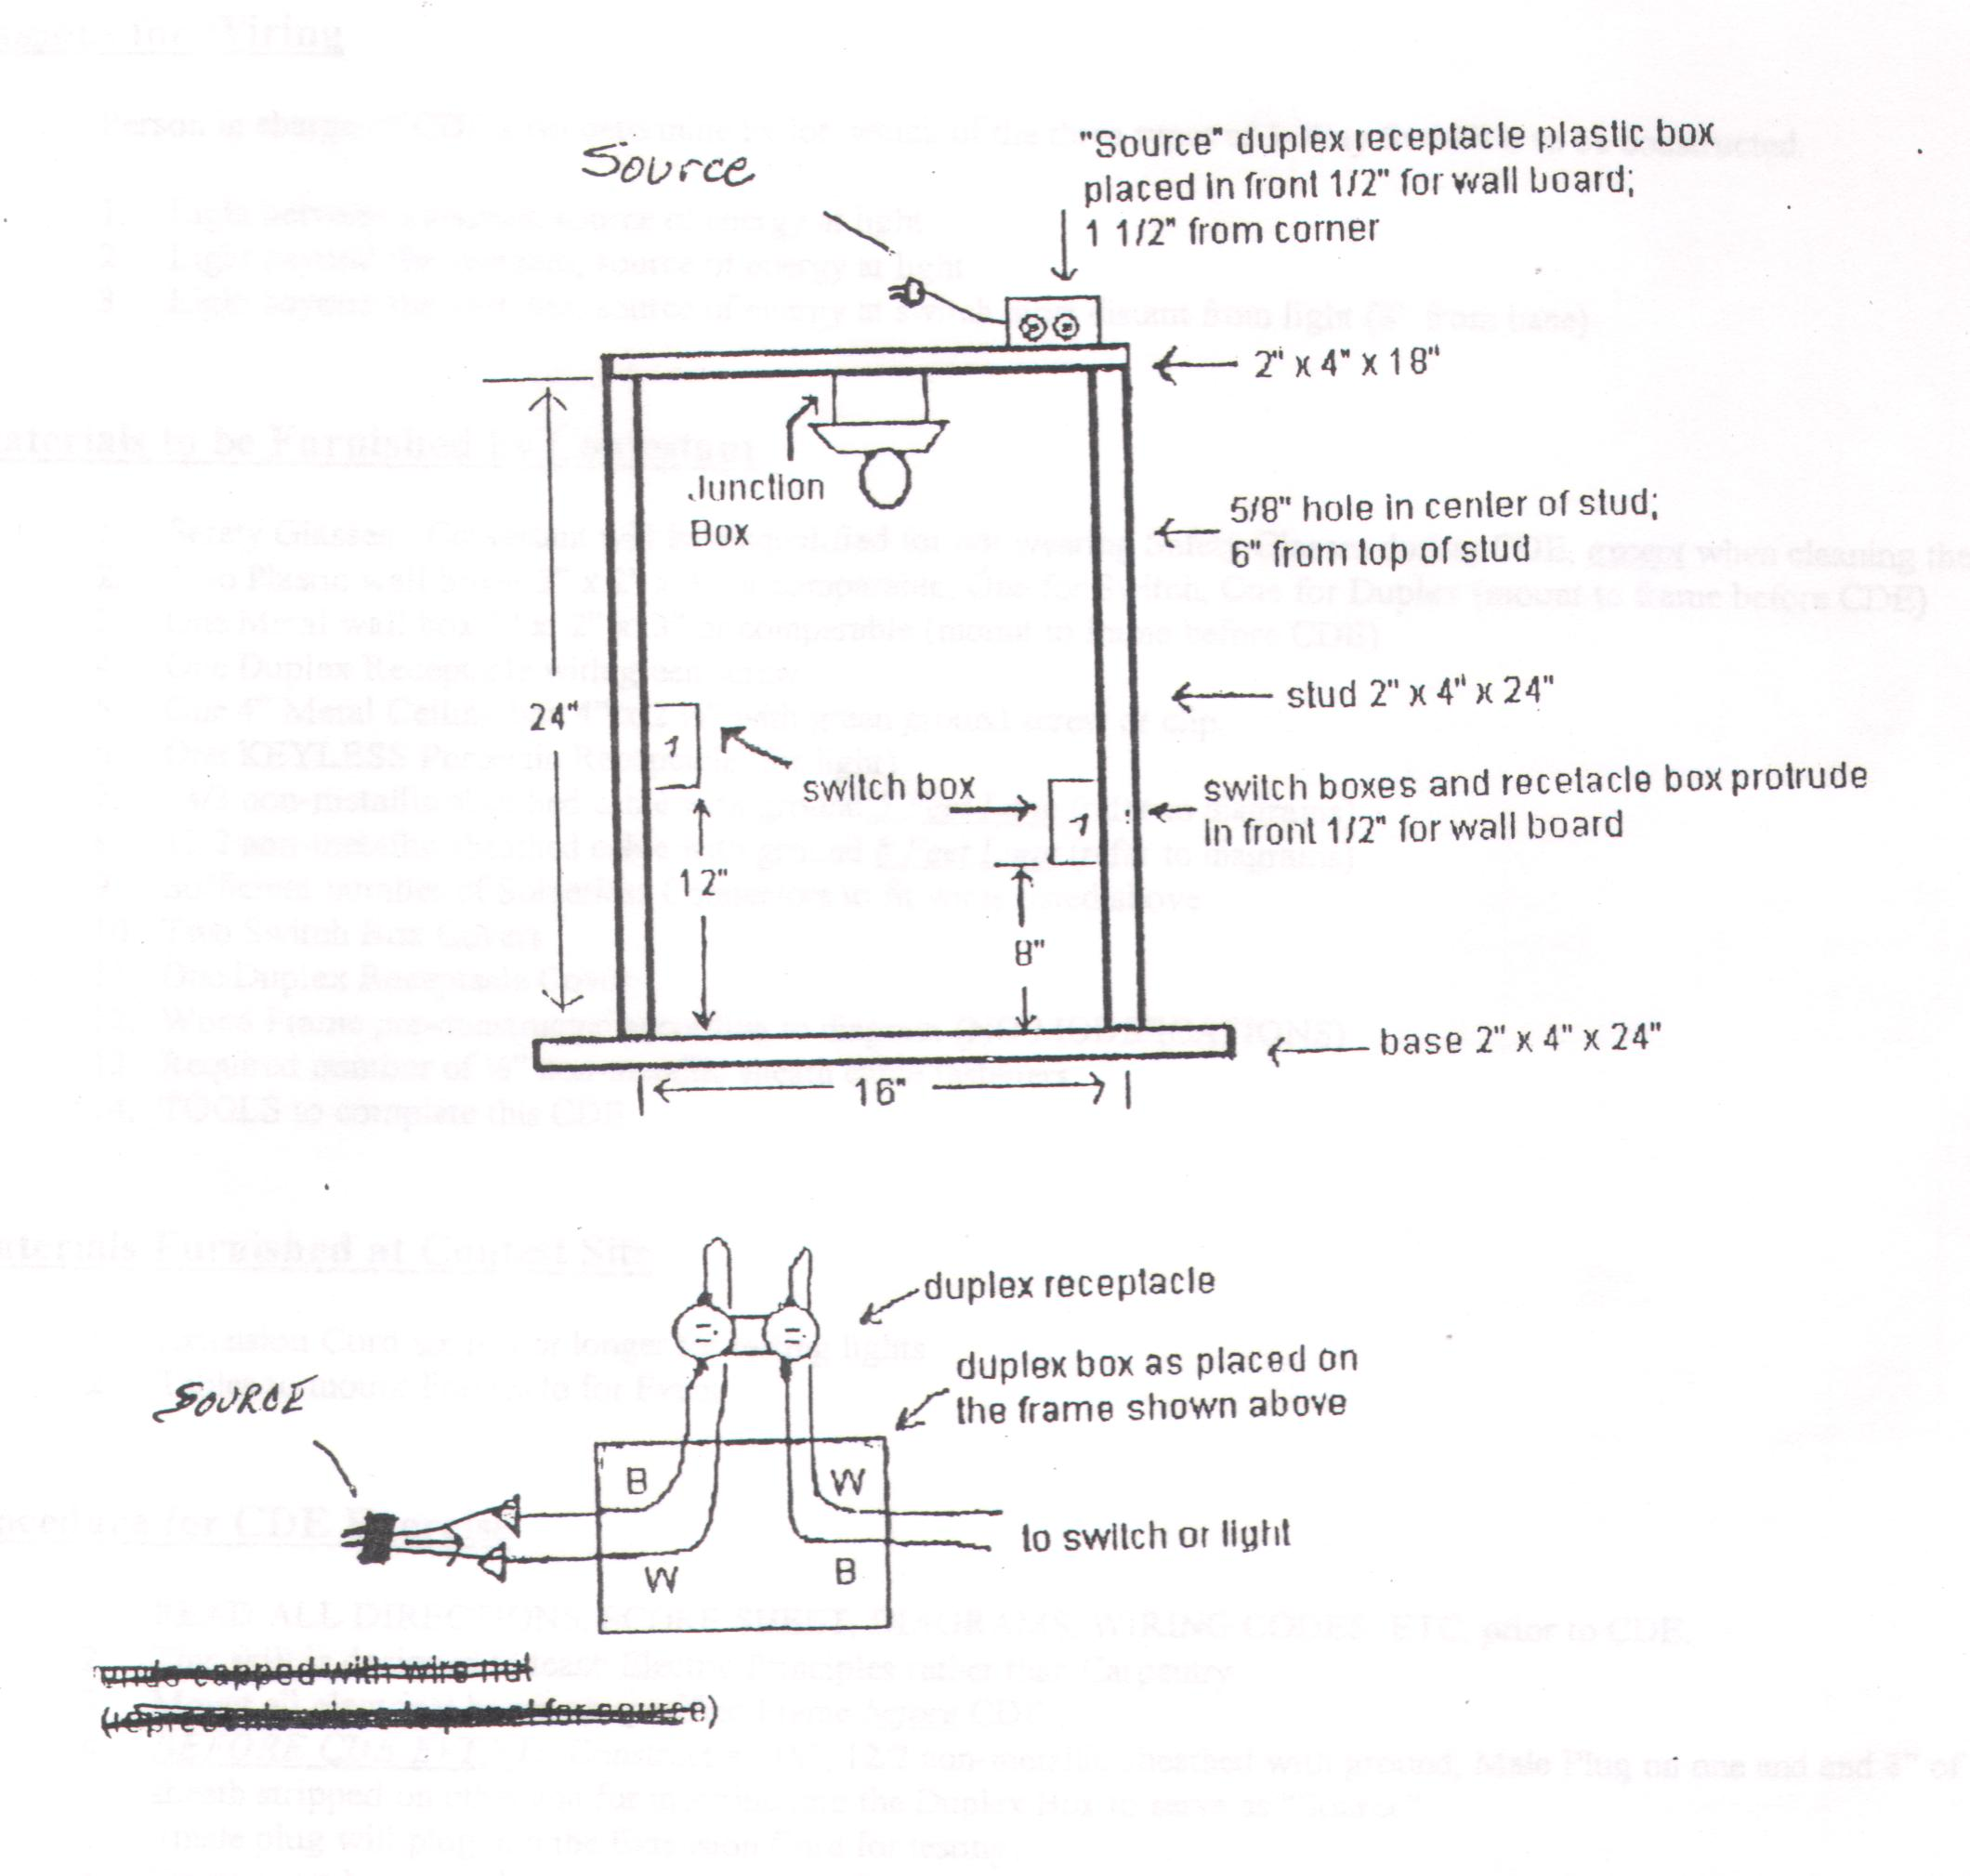
NOTE: Refer to Illustration of Frame Construction, Box Placement and 5/8” Hole locations and measurements.

3-WAY SWITHCH INSTALLATION

SCORE SHEET

Contestant |  | 1 | 2 | 3 | 4 | 5 | 6 | 7 | 8 | 9 | 10 | 11 | 12
Operates Properly | 50 Points
Correctly Wired | 50 Points
Total | 100
Rank

NOTE: Subtract one to five points from the above

Total for each deficiency below.

OUTSIDE APPEARANCE

- Boxes properly installed (1/2” past wall stud)

- Wires properly installed in boxes.
(Outside insulation goes under Romex connectors)

- Neat corner bends. (very little daylight between wire
and wall stud)

- Wires properly installed (staple hold wires firmly in
place but does not cut into outside insulation)

- Wires going into plastic box must be stapled within
8” of the box

INSIDE APPEARANCE

- Insulation properly stripped (1/2” to 5/8”). Inside
insulation should come up to terminal but not go under
terminal

- Terminal attachment (wires wrapped clockwise)

- No nicked or cut insulation

- Splices properly turned (clockwise)

- Insulation under Solderless connectors
(no bare wire exposed)

- Loose wires (wires held tight under terminal)

- Grounding screws installed properly

- Length (sheathing stripped to no less than ¼” from the inside back of the box but no more that ¾”. Unsheathed wires should extend at least 8” from the inside back of the box)

- Grounding wires in plastic wall box must be spliced
together with Solderless connectors

- Grounding wires in metal boxes must be spliced together
with Solderless connectors with one wire
connected to each metal box with screw and green pigtail

- A single ground wire in the plastic wall box must be
grounded to the switch

